CREATE:

mysql> create database mydb;

Query OK, 1 row affected (0.02 sec)

mysql> use mydb;

Database changed

mysql> create table shivani(Regno int(10), Name varchar(50),Gender char(1),MobileNo int(11));

Query OK, 0 rows affected, 2 warnings (0.06 sec)

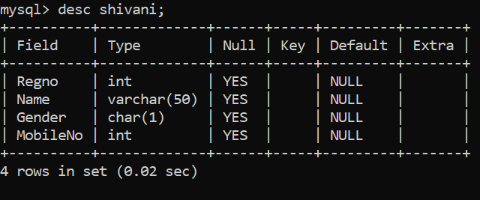

mysql> insert into shivani values(192211056,'Shivani','F',639841260);

Query OK, 1 row affected (0.03 sec)

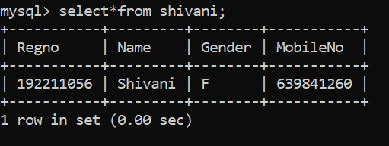

ALTER:

mysql> alter table shivani

-> add deptname char(50);

Query OK, 0 rows affected (0.04 sec)

Records: 0 Duplicates: 0 Warnings: 0

mysql> alter table shivani

-> drop column MobileNo;

Query OK, 0 rows affected (0.02 sec)

Records: 0 Duplicates: 0 Warnings: 0

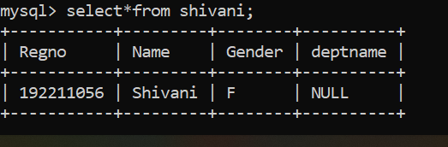

mysql> update shivani set deptname='CSE';

Query OK, 1 row affected (0.01 sec)

Rows matched: 1 Changed: 1 Warnings: 0

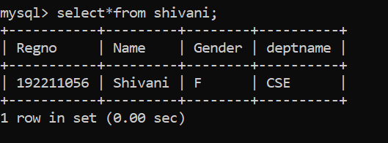

DROP:

mysql> drop table shivani;

Query OK, 0 rows affected (0.02 sec)

mysql> desc shivani;

ERROR 1146 (42S02): Table 'mydb.shivani' doesn't exist